

Black Commercial 2 ply EP80 Fabric insertion SBR Rubber 85° shore
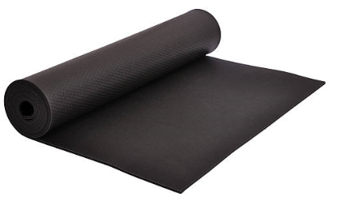
WJ127
Black Commercial quality 2 ply EP80 Fabric Insertion SBR 80° is a Commercial Grade, Commercial Quality Styrene Butadiene rubber blend with an EP80 fabric insertion.
N.B. All our sheeting can be supplied plain or with self-adhesive backed tape (SAB). Rubber Strip to bespoke sizes are available along with customised sheets/gaskets. Please email your enquiry details to
Material Profile: See below Thickness: 0.5mm to 50mm
Sheet Size: 1.4m wide in 10m rolls Finish: Smooth (SS)
Cutting: Standard press-tools
Other grades, colours and finishes are available
– subject to minimum batch quantities

TECHNICAL DATA

STOCK ROLL SIZES [M X M X MM] | SURFACE FINISH | WEIGHT [KG/M2]
6mm x 1400mm x 10m | SS | 9.96

SPECIFICATIONS COMPOUND

SPECIFICATIONS COMPOUND | VALUES [TYPICAL]
Colour | Black

SPECIFICATIONS COMPOUND | VALUES [TYPICAL]
Compound | SBR
Density [specific gravity] | 1.60
Hardness [Degrees Shore A] | 85° ± 5°
Tensile Strength Kg/cm2 [Polymer] | 40
Elongation at break | 175
Minimum Temperature | -20°C
Maximum temperature | +70°C
Failure to select the correct materials or products can result in damage to plant and equipment and personal injury. In specific applications, where critical conditions exist, we suggest you contact us, and we will consider with you the most suitable material or product. However, information supplied by William Johnston & Company Limited is intended only as technical co-operation and as a guide to the various uses of different products. No warranty is given in respect of information or recommendations by William Johnston & Company Limited which are only given for guidance and without any guarantee. The customer must satisfy themselves on the suitability of the material or product for the intended purpose. The correct fitting of products particularly is the responsibility of the customer.

