
ECOSCRAPE – MULTI-FABRIC REINFORCED RUBBER
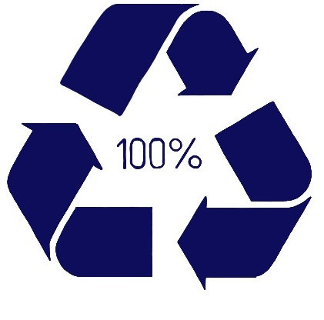

Ecoscrape is manufactured using recycled high-quality tyres resulting in an economical and environmentally friendly product. The fully vulcanised rubber has inclusion of majorly dispersed fibres creating a unique compound that exhibits outstanding strength and durability.
Ecoscrape can withstand harsh conditions like exposure to ozone and low temperatures. It’s available in flat sheets for die cut parts and can be slit to exacting widths. Ecoscrape can be moulded to create bespoke parts for our valued customers.

Ecoscrape is an excellent economical choice for applications where superior tear resistance and durability are required. Applications include but are not limited to trucking, baffles/ close-outs, air dams, splash shields, mud guards and mud flaps. Agricultural used for scrapers, step pads, cab mats, engine close outs and grain deflectors. Many mining, railroad and anti- vibration applications.

ECOSCRAPE – MLUTO-FABRIC REINFORCED RECYCLYED RUBBER
 | TEST METHOD | VALUES
 | TEST METHOD | FPS UNITS | METRIC UNITS
COLOUR | - | - | Black
DENSITY | ASTM D297 | G/CM3 | 1.25 g/cm3
HARDNESS | ASTM D2240 | A SCALE | 80 Sh A
TENSILE STRENGTH WITH GRAIN | ASTM D412 | Mpa | 5.0
ULTIMATE ELONGATION ACROSS GRAIN | ASTM D412 | % | 45%
ABRASION RESISTANCE (max) | ASTM D5963 | mm3 | 110mm3
TEAR STRENGTH ACROSS GRAIN | ASTM D624 | kN/m | 52
TEMPERATURE RANGE |  | Celsius | -40 to + 75º C
LOW TEMPERATURE BRITTLENESS@ -40C | ASTM D2137-11 |  | Non brittle in both directions under 7  x magnification
FLAMMABILITY – MAXIMUM BURN RATE 100mm/mm | FMVSS 302 | Mm/mm | 100 max

Failure to select the correct materials or products can result in damage to plant and equipment and personal injury. In specific applications, where critical conditions exist, we suggest you contact us, and we will consider with you the most suitable material or product. However, information supplied by William Johnston & Company Limited is intended only as technical co-operation and as a guide to the various uses of different products. No warranty is given in respect of information or recommendations by William Johnston & Company Limited which are only given for guidance and without any guarantee. The customer must satisfy themselves on the suitability of the material or product for the intended purpose. The correct fitting of products particularly is the responsibility of the customer.

