THE PHYSICS OF RUBBER

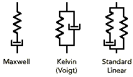
Rubber is composed of long chains of randomly oriented molecules. These long chains are subject to entanglement and cross-linking. The entanglement has a significant impact on the viscoelastic properties such as stress relaxation. When a rubber is exposed to stress or strain energy, internal rearrangements such as rotation and extension of the polymer chains occur. These changes occur as a function of the energy applied and the duration and rate of application, as well as the temperature at which the energy is applied.
A rubberÌs response to an applied energy can be energy storage (elastic) or energy dissipation (viscous). For sealing elastomers, the elastic component of response is most important. An applied stress induces a corresponding strain which creates contact stress (or seal-ing force). As the polymer chains rearrange to reduce this internal energy, or stored force, a loss of sealing force occurs.
Rubber products are typically cured at high temperature and pressure. The addition of curatives and accelerators forms cross-links between the polymer chains or backbone. It is this network of cross-links that largely determines the physical properties of tensile, elongation and compression set.
Fillers play a large role in rubber technology. Carbon black and silica fillers can serve to improve the hardness, abrasion resistance, tensile properties and tear strength. Non-black fillers, such as titanium dioxide and barium sulfate can offer pigmenting properties for part identification, as well as improved stability in strong oxidizing environments. However, the viscoelastic response and hysteresis losses are greatly enhanced by the use of fillers.
The physical properties of an elastomer vary with the test conditionsÛespecially temperature. The rate of application of a load also has an effect, as does previous stress history.
Relationship of Cross-link Density and Physical Properties
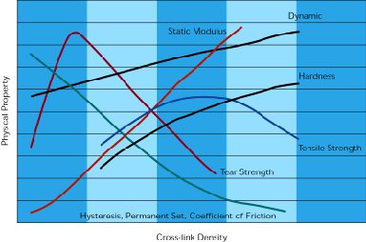

ELASTOMER PROPERTIES

Hardness
The hardness of an elastomer is measured based on the depth of indentation by a standard size and shape impacting gauge. The hardness is obtained by comparing the difference between a small initial force and a much larger final force. The International Rubber Hardness Degrees (IRHD) scale has a range of 0 to 100, corresponding to elastic modulus of 0 (0) and infinite (100), respectively. The mea-surement is made by indenting a rigid ball into the rubber specimen.
The Shore A scale is the most prevalent in the United States. A ÏfrustoconicalÓ indentor with a spring force that decreases with increasing indentation is used. The readings range from 30 to 95 points. Harder materials use a pointed conical indentor with the Shore D scale. The results of the Shore A scale and the IRHD scale are approximately equal over the same range of resiliency. In compounds with unusually high rates of stress relaxation or deformation hysteresis, the difference in dwell time in the two readings may cause different results. Also, the results of any hardness test depend on the elastomer thickness. Specified thickness should be used when conducting these tests.
Due to the mechanical limits of the test instruments, hardness measurements are rarely expressed more precisely than 5 points.
Tensile Strength vs. Hardness
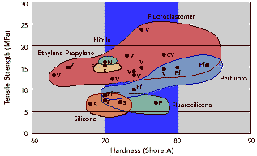
The surface indentation or hardness usually does not bear any relation to the ability of an elastomeric part to function properly. Hardness is a measure of a materialÌs response to a small surface stress. Stiffness and compressive modulus measure the response to large stresses of the entire elastomeric part.
Test Methods: ISO 48 (IRHD), ISO 7619 (Shore A), ASTM D1415 (IRHD), D2240 (Shore)
Hardness vs. Temperature
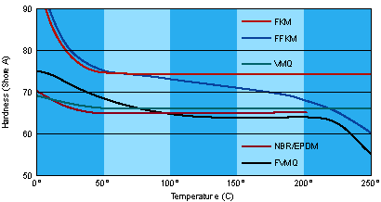
Hardness (IRHD) vs. Young's Modulus (M)
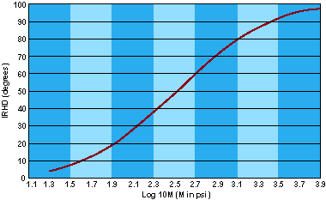
Tensile Stress-strain
Tensile strength is the maximum tensile stress reached in stretching a test piece (either an O-ring or dumbbell).
Elongation: The strain, or ultimate elongation, is the amount of stretch at the moment of break.
Modulus: Also called ÏMod 100,Ó this is the stress required to produce a given elongation. In the case of ÏMod 100,Ó the modulus would be the stress required to elongate the sample 100%. In elastomers, the stress is not linear with strain. Therefore the modulus is neither a ratio nor a constant slopeÛbut rather denotes a point on the stress-strain curve. Tensile tests are used for controlling product quality and for determining the effect of chemical or thermal exposure or an elastomer. In the latter case, it is the retention of these physical properties, rather than the absolute values of the tensile stress, elongation or modulus, that is significant.
Test Methods: ISO 37, ASTM D412
Stress vs. Strain
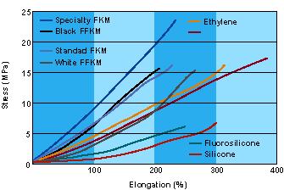
Bulk Modulus/Resiliency
Elastomers are often treated as incompressible materials for analytical convience. However, in many instances the compressive response of elastomers is very important.
Bulk or Static Modulus. The bulk modulus is a property of a material which defines its resistance to volume change when compressed. It can be expressed as:
K = p/ev
Here p is the hydrostatic pressure, ev is the volumetric strain and K is the bulk modulus. In practice, a positive volumetric strain is defined as a decrease in volume.
Measuring a materialÌs strain response to an applied pressure is a simple test for bulk modulus. The bulk modulus can be expressed as the derivative (slope) of the pressure-strain curve.
Relationships between YoungÌs modulus E, the shear modulus G, and PoissonÌs ratio v are related by:
E = 3 K (1 Ò 2v)
E = 2 G (1 + v)

Test Methods: ISO 774, ASTM D575
Bulk Modulus Test Assembly

Rebound Resilience. When a pendulum hammer impacts a rubber specimen from a certain distance or angle, the degree or distance that the pendulum does not return is an indication of the energy lost during the deformation.
Test Methods: ISO 4662, ASTM D1054, D2632

Compression Set/Creep

Compression set is a measurement of the ratio of elastic to viscous components of an elastomerÌs response to a given deformation. Longer polymer chains tend to give better Ïset resistanceÓ because of the improved ability to store energy (elasticity). Compression set measurement standards call for a 25% compression for a given time and temperature. The cross-section is measured after the load is removed. Compression set is the percentage of the original compression (25%) that is not recovered. This test may be conducted on cylindrical disks or O-rings. At the end of the test, the samples are removed and allowed to cool at room temperature for 30 minutes before measuring. After a load is released from an elastomer, the difference between the final dimensions and the original dimensions is considered the compression set.

Compression Set Test Assembly


The use of compression set measurements is most beneficial for production quality control, indicating the degree of curing. Elastomers with high compression set values may require special considerations for gland design and handling. Compression set is a relatively simple test to perform, and as such, may not yield the type of predictive information desired for custom sealing applications.

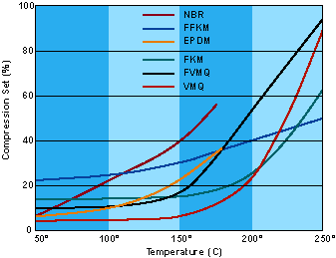

When a constant load is placed on an elastomer, the deformation is not constant, but rather it increases gradually with time. Terms used to describe this behavior are relaxation or creep. These properties, including compression set, are a result of physical (viscoelastic) and chemical (molecular structure) changes in an elastomer.

Test Methods:
ISO 815 (Ambient & High Temp.)
ISO 1653 (Low Temp.)
ASTM D395 (Ambient & High Temp.)
D1229 (Low Temp.)
Retained Sealing Force Test Assembly
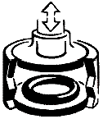
Stress Relaxation/Retained Sealing Force

Elastomers are viscoelastic in nature. When deformed, energy storage is always accompanied by some energy dissipation. The entanglements of the long elastomer chains act as obstructions to the movement of the polymer chains. These obstructions enable the elastomer to store energyÛan elastic property. The rearrangements of the polymer chains are dependent on the specific chemical structure, time, temperature and deformation rate. Since elastomers are viscoelastic, the stored energy decreases over time. This decrease of the stored energy (seen as contact sealing force) over time is known as stress relaxation. In other words, stress relaxation is the change in stress with time when the elastomer is held under constant strain.

Common instruments for measuring stress relaxation are Lucas and Wykeham Farrance. There are three standard methods:

Method AÛcompression is applied at test temperature and all force measurements are made at test temperature.

Method BÛcompression and force measurements are made at ambient temperature.

Method CÛcompression is applied at ambient temperature and all force measurements are made at test temperature.
The three methods do not give the same values of stress relaxation. The resulting force measurements in all methods can be normalized to the initial counterforce, and expressed as a Retained Sealing Force percent.

Test Methods:
ISO 8013ÛCreep Strain Relaxation
ASTM D412ÛCreep Strain RelaxationÛTensile Properties
ISO 3384ÛStress Relaxation

Sealing Force Retention

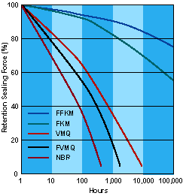

Shear Modulus/Tear Strength/Dynamic Stress-Strain

Shear Modulus: The shear modulus is an important property in design calculations for elastomers used in shear. The test methods typically require that the test sample be bonded to metal plates. The resulting ratio of the shear stress to shear strain is the shear modulus.

Test Methods:
ISO 1827

Tear Strength: For considerations of removing a molded part from the production mold, or for determining the ease of which a tear can start and propogate in application, tear strength is an important property. Different test methods use different shapes and methods for applying a tearing force.

Test Methods:
ISO 34, 816
ASTM D624

Dynamic Stress-Strain: In cyclic or dynamic applications, the viscoelastic properties of elastomers are very important. Lost energy, in the form of heat, arises from molecular friction as a result of an applied load. The percentage energy loss per cycle is known as Ïhysteresis.Ó When the loading and unloading cycle continues, the shape and position of the hysteresis curve changes.

The response of a specimen to a sinusoidal deformation can best exhibit the dynamic properties of an elastomer. The elastic component of the elastomer is responsible for the in-phase stress, while the viscous component is responsible for the out-of-phase stress. The amount by which the strain response lags the resultant of the two stresses (in-phase and out-of-phase) is known as the phase or loss angle, ï. The more viscous an elastomer, the greater the phase or loss angle. The tangent of this angle Ïtan ï,Ó in the simplest terms, is the ratio of the viscous modulus to the elastic modulus.

Dynamic Properties for Various Sealing Elastomers

PROPERTY | AEGIS | FLUORO ELASTOMER | EPDM | NITRILE | SILICONE | FLUORO SILICONE

Tensile Strength | GOOD | EXCELLENT | EXCELLENT | EXCELLENT | FAIR | FAIR
Abrasion Resistance | FAIR | GOOD | GOOD | GOOD | POOR | POOR
Tear Resistance | FAIR | FAIR | EXCELLENT | EXCELLENT | POOR | POOR

Abrasion/Coefficient of Friction/Electrical Properties
Abrasion: Resistance to wear may be a very important property in many applications. Standard test methods use a uniform abrading material and application. Abrasion is a measure of the amount of material lost in these tests.
Test Methods: ISO 4649 (ISO), 5470 (Taber) ASTM D394 (Du Pont), D1630 (NBS), D2228 (Pico), D3389 (Taber)
Coefficient of Friction: The coefficient of friction is the ratio of the frictional force between two bodies, parallel to the contact surface, to that of the force normal to the contact surface. Breakaway friction is the threshold friction coefficient as motion begins, and running friction is the steady-state friction coefficient as motion continues.
Volume Resistivity: The measure of electrical resistance through a volume of elastomer. This property is useful in predicting conductive or antistatic behavior. ASTM D991
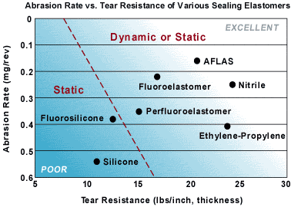
Elastomer Properties
Electrical Properties Dielectric Constant (Permittivity): The ratio of the capacitance of a capaci-tor filled with the elastomer to that of the same capacitor having only vacuum as the dielectric. ASTM D150
Dielectric Strength: The measure of the ability of an elastomer to resist current flow when a voltage is applied. ASTM D149
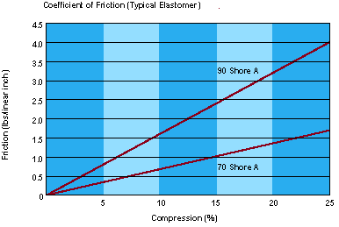
Electrical Properties: The electrical properties of elastomers can be changed by the addition of insulating or conducting fillers. In general, high electrical conduc-tivity yields a lower buildup of static electricity within the elastomer.
Electrical Properties of Various Sealing Elastomers
 | Volume Resistivity (Ohm-cm) | Dielectric Constant (23C, 1kHz) | Dielectric Breakdown (kV/0.15mm)
EPDM | 1.0 x 10¹⁵ to 1.0 x 10¹³ | 2.3 - 2.8 | -
FKM | 5.8 x 10¹⁰ to 3.5 x 10¹⁵ | 8.8 - 10.7 | -
AEGIS | 1.4 x 10¹⁷ | 2.4 | 7.0
Miscellaneous Properties
Adhesion: The use of bonded elastomer-metal or elastomer-plastic assemblies typically requires the use a bonding agent and surface preparation. Care must be taken in selecting a bonding agent which will be compatible with the process chemistry and/or temperature. Specific tests are available to determine the strength of the adhesive bond.
Radiation: Exposure to radiation may cause additional cross-linking or degradation. While the type of radiation and energy is very important, gamma radiation is considered typical exposure for most elastomer testing. AEGIS perfluoroelastomers can withstand radiation dosages of 1 Mrad. At 10 Mrad dosages, moderate damage will occur to the physical properties(>40% change).
Transparency: The optical clarity of AEGIS SC1090 provides opportunities for applications where minimal absorbancy is desired.
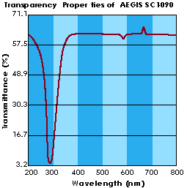

Back

