
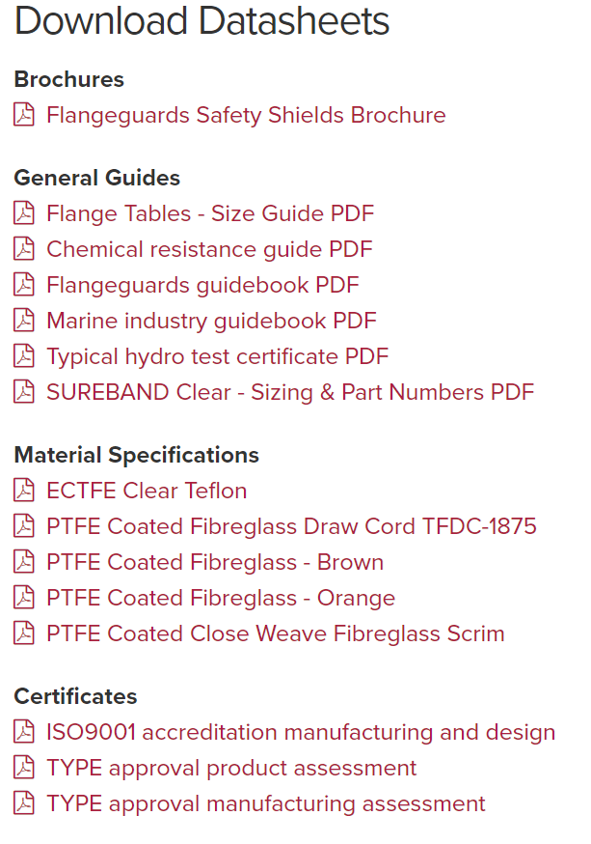
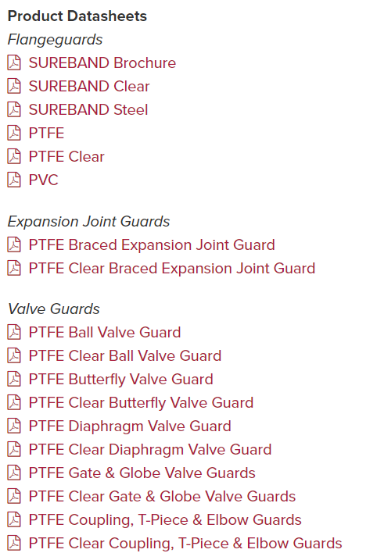
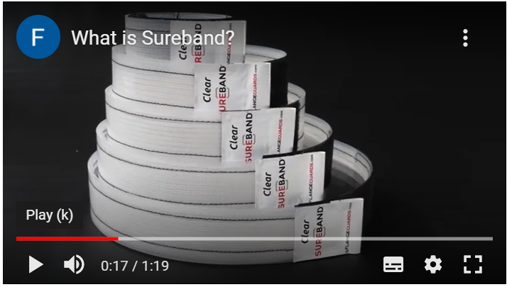
William Johnston & Company Limited are proud to be the exclusive Scottish Distributor for Flangeguards Limited.
Pipe safety shields also known as flange guards are used in a variety of industries, where their primary application is the prevention of harmful spray-outs and mist formation from failing pipe joints, of toxic, corrosive, and dangerous liquids such as acid, oil, or steam.

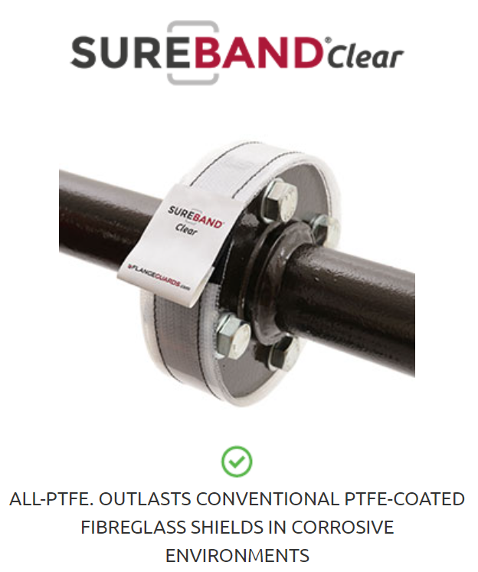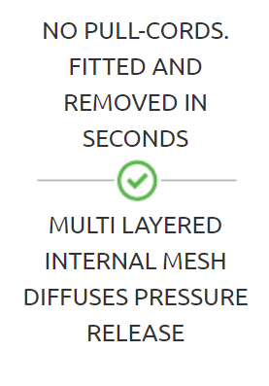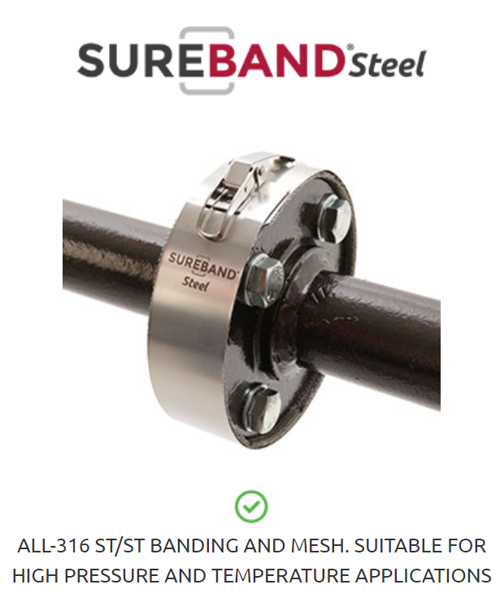
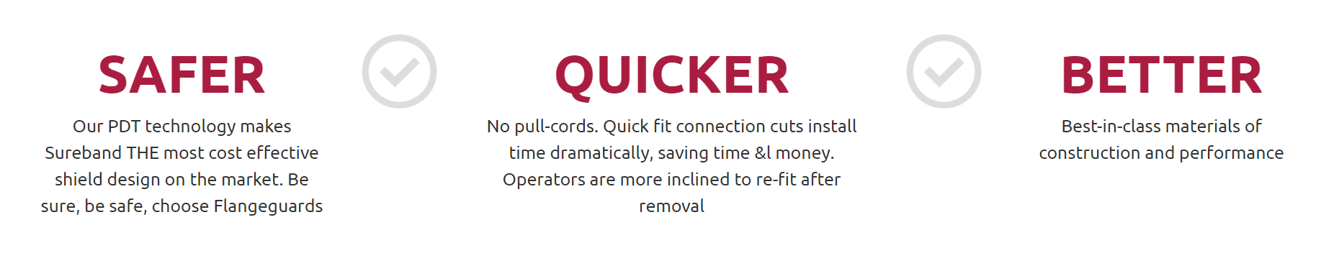
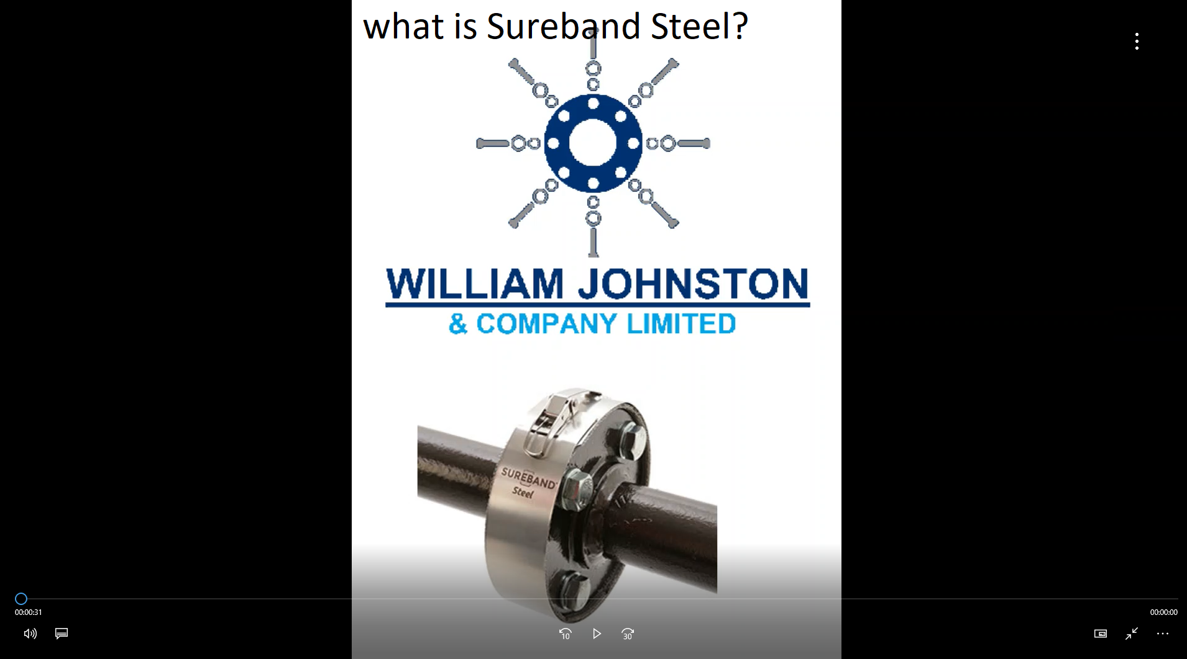
1. Multi-layered steel mesh
Critical for safety, to avoid spray and unwanted mist formation (which is a consequence of ill-fitting shields with no mesh). The mesh effectively diffuses a pressure release, creating a safe vertical drip.
2. Quick-connection latch
Provides quick and easy fitting & removal without any special tools. This is very useful for harsh environments where gloves, chem-suits and other conditions make installation difficult
3. All 316 stainless steel as standard
No weak points, 3.1b material certificates available on request.

Safety or spray shields offer the last line of defence. They are not designed to contain the leak indefinitely, but to prevent the harmful spray outs resulting in fire or explosions causing considerable plant down time, capital expenditure and even loss of life.
If you have a technical question about our products, please contact us.

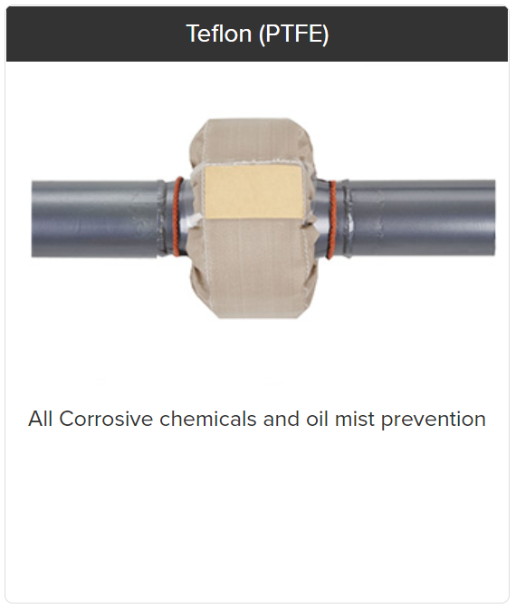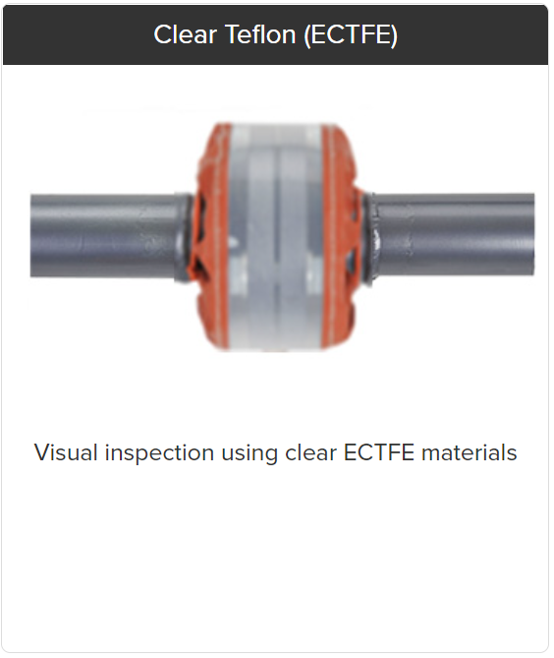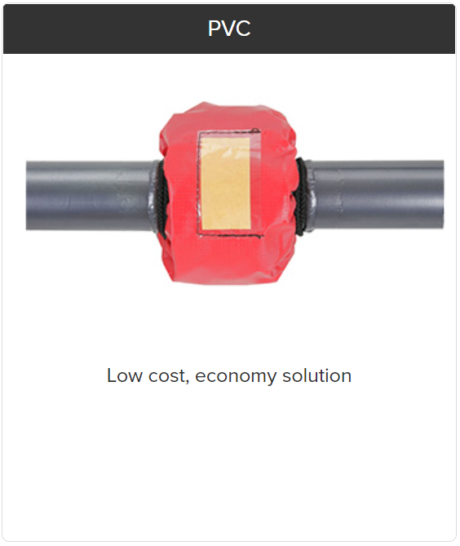
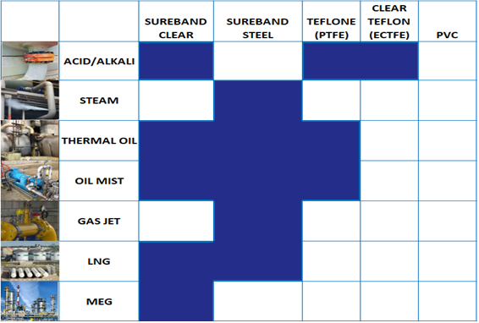
We can supply Flange Guards for all different configurations of valves, elbows, couplings, and expansion glands.
Speak to one of our experts to see how we can assist.
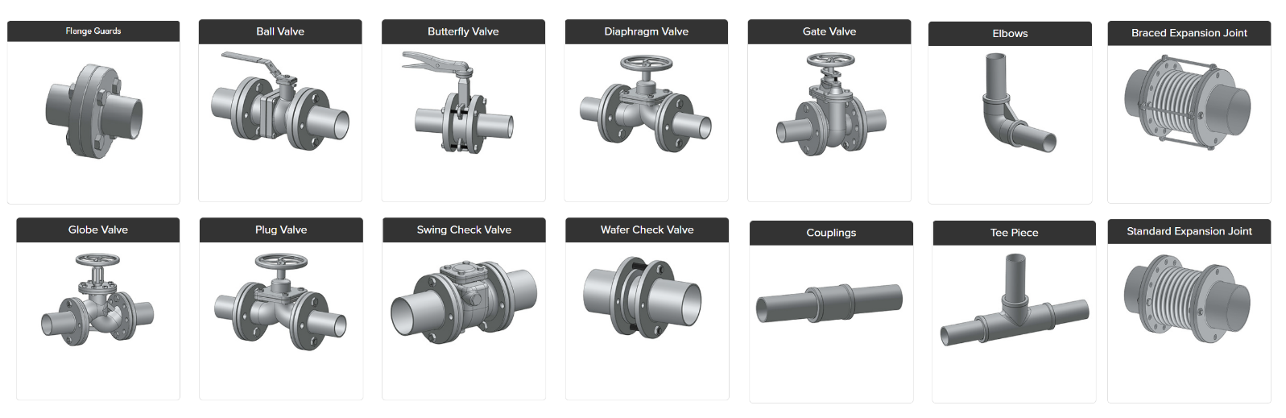

Safety Shield Specifications
If you have any technical questions about our Pipe Safety Shields, please contact us.

SUREBAND Clear Safety Shields
Innovative design comprises all-PTFE materials (no fibreglass) with outer ETFE and multi-layer ECTFE mesh inner. Compatible with practically all corrosive chemicals (incl. caustic, high concentration sulphuric). Comes complete with litmus indicator patch and quick-fit Velcro fastening method (no pull cords).
This shield is typically used for acids, caustics, solvents, fuel, lubrication, and seal oil applications. In addition to the pipe joint types listed on this website, the Sureband Clear shield can be made to fit a wide range of other fittings such as valves.
Max working temp: 230 °C / 450 °F
Flange Ratings: ANSI 150 - 600lb / DIN PN6 - PN40
Pipe sizes: Standard; ¼" (10mm) - 24" (600mm). Larger sizes available please contact us
Applications: Standard; Flanges, Elbow, Tees, Couplings. Other types available please contact us.

SUREBAND Steel Safety Shields
This shield comprises outer 316 stainless steel band, inner multi-layered stainless steel mesh and external quick-release clamp. The key design feature is the internal mesh which effectively diffuses all pressure from the release, resulting in a safe drip. Equally important is the exact alignment of the shield and 'crimped' central mesh section, as other ill-fitting shields may create additional lateral spray-outs or dangerous mist formation.
Typically used for fuel, lubrication, seal & hydraulic oil, steam, and other chemicals. Its design and materials of construction make it suitable for applications involving high temperature and pressure. Currently only available for flanges - though we can supply shielding solutions for 'special' applications so feel free to contact us for further consultation.
Max working temp: 500 °C / 930 °F
Flange Ratings: ANSI 150 - 1500lb / DIN PN6 - PN100
Pipe sizes: Standard; ¼" (15mm) - 24" (600mm). Larger sizes available, contact us
Applications: Flanges.

Teflon (PTFE) Safety Shields
Our most popular shield, compatible with practically all corrosive chemicals (incl. caustic, high concentration sulphuric) due to the technical fabric and Teflon/Kevlar thread used for stitching. See our 'chemical resistance guide' for further clarification.
This shield is typically used for acids, caustics, solvents, fuel, lubrication, and seal oil applications. In addition to the pipe joint types listed on this website, the PTFE shield can be made to fit a wide range of other fittings such as valves, pumps, expansion joints and hoses (contact us for further details).
Max working temp: 235 °C / 450 °F
Flange Ratings: ANSI 150 - 600lb / DIN PN6 - PN40
Pipe sizes: Standard; ¼" (10mm) - 24" (600mm). Larger sizes available please contact us.
Applications: Standard; Flanges, Elbow, Tees, Couplings. Other types available please contact us.

Clear Teflon (ECTFE) Safety Shields
This shield is generally used for applications where sight of the flange/joint must not be obscured. Thus, liquid releases can be seen within the shield, providing visual indication. It should be noted however, that we do not recommend this shield for applications where external liquid / condensation may result in a false indication of leakage.
The shield is suitable for a range of corrosive chemicals due to the technical fabric and Teflon/Kevlar thread used for stitching. See our 'chemical resistance guide' for further clarification. For strong acids and higher temperatures and pressures, please consider the standard PTFE or stainless steel shield. Typically used for acids, caustics, solvents, fuel, lubrication, and seal oil applications. In addition to the pipe joint types listed on this website, the PTFE-CLEAR shield can be made to fit a wide range of other fittings such as valves, pumps, expansion joints and hoses.
contact us for further details.
Max working temp: 150 °C / 300 °F
Flange Ratings: ANSI 150 - 300lb / DIN PN6 - PN40
Pipe sizes: Standard; ¼" (10mm) - 24" (600mm). Larger sizes available please contact us.
Applications: Standard; Flanges, Elbow, Tees, Couplings. Other types available please contact us.

316 Steel Safety Shields
This shield comprises outer 316 stainless steel band, inner 4-layer stainless steel mesh and external quick-release clamp. The key design feature is the internal mesh which effectively diffuses all pressure from the release, resulting in a safe drip. Equally important is the exact alignment of the shield and 'crimped' central mesh section, as other ill-fitting shields may create additional lateral spray-outs or dangerous mist formation.
Typically used for fuel, lubrication, seal & hydraulic oil, steam, and other chemicals. Its design and materials of construction make it suitable for applications involving high temperature and pressure. Currently only available for flanges - though we can supply shielding solutions for 'special' applications so feel free to contact us for further consultation.
Max working temp: 500 °C / 930 °F
Flange Ratings: ANSI 150 - 1500lb / DIN PN6 - PN100
Pipe sizes: Standard; ¼" (15mm) - 24" (600mm). Larger sizes available, contact us
Applications: Flanges.

PVC Safety Shields
This shield is made from heat-sealed PVC and is designed to provide a 'budget' or short-term solution for low corrosion, pressure, and temperature applications. Typically used for water-based liquids and particularly low-concentration chemicals. Each shield comes with external litmus indicator patch.
Max working temp: 60 °C / 150 °F
Flange Ratings: ANSI 150 - 300lb / DIN PN6 - PN25
Pipe sizes: ¼" (10mm) - 24" (600mm). Larger sizes available, contact us
Applications: Flanges, Elbows, Tees, Couplings

