

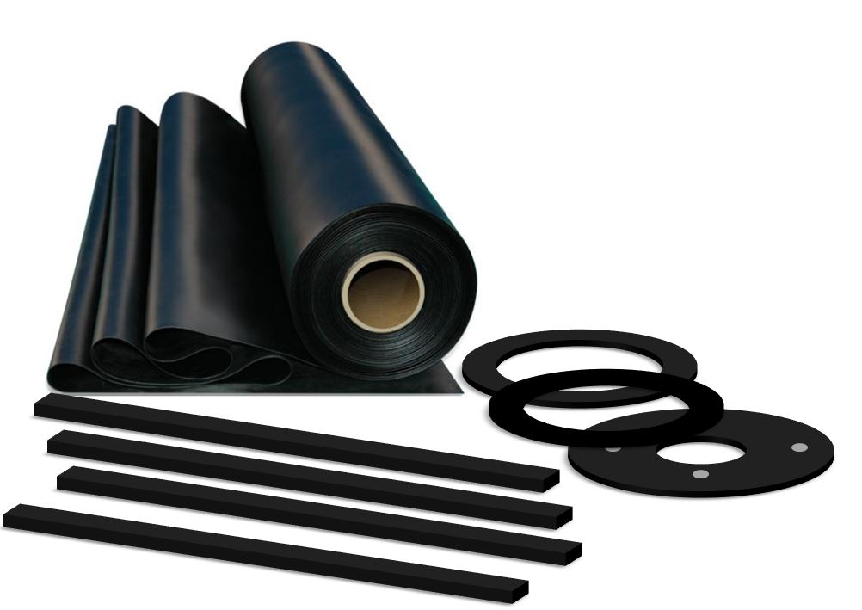

## TECHNICAL DATA

**image004**

**Inverness +44 (0) 1463 238 673**  **Head Office +44 (0) 141 620 1666 (8 lines)** **Ashford +44 (0) 1233 330 766**

[**sales@williamjohnston.co.uk**](mailto:sales@williamjohnston.co.uk)[**www.williamjohnston.co.uk**](http://www.williamjohnston.co.uk)

|  |  |
| --- | --- |
| PRODUCT NAME | Commercial EPDM 60 |
| DESCRIPTION | High grade EPDM suitable for appliations where good ozone and weather resistance is required. Also suitable for some mineral oils |
| THICKNESS (mm) | 1mm – 25mm |
| SHEET SIZE (M) | 1.4M X 5M, 10M & 20M -thickness dependant |
| FINISH | Plate/Plate |
| MATERIAL | EPDM |
| APPLICATION | General Purpose |
| INSERTION | No |
| CHEMICAL RESISTANCE | PLEASE REFER TO OUR CHEMICAL DATA SHEET |

|  |  |
| --- | --- |
| **SPECIFICATIONS COMPOUND** | **Values [typical]** |
| COLOUR | Black |
| COMPOUND | EPDM |
| DENSITY [SPECIFIC GRAVITY] g/cm³ | 1.15 |
| HARDNESS [DEGREES SHORE A] +/-5 | 60 |
| TENSILE STRENGTH MPa | 10 |
| ELONGATION AT BREAK % | 300 |
| MINIMUM TEMPERATURE °C | -30 |
| MAXIMUM TEMPERATURE °C | +130 |
| COMPRESSION SET (70°C 22 hours) % | 30 |

## 

## 

## 

## 

## 

## 

*As the companies’ products are used in multiple applications and as the company has no control over the method of their use, the company excludes all conditions or warranties, expressed or implied by statute or otherwise. Any technical co-operation is given for customers’ assistance only and without liability on the part of the company.*