

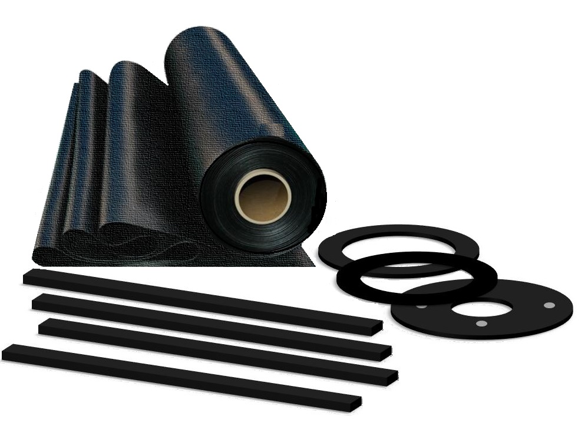

## TECHNICAL DATA

**image004**

**Inverness +44 (0) 1463 238 673**  **Head Office +44 (0) 141 620 1666 (8 lines)** **Ashford +44 (0) 1233 330 766**

[**sales@williamjohnston.co.uk**](mailto:sales@williamjohnston.co.uk)[**www.williamjohnston.co.uk**](http://www.williamjohnston.co.uk)

|  |  |
| --- | --- |
| PRODUCT NAME | BS2752 C60 |
| DESCRIPTION | A high grade pure CR (Chloroprene Rubber) manufactured under strict control to BS2752/C40 specification. Good resistance to Weathering, Ozone, Salt Water and some Greases. Self-extinguishing. |
| THICKNESS (mm) | 0.5 to 6 |
| SHEET SIZE (M) | 1.4 x 10 |
| FINISH | Plate/plate |
| MATERIAL | Chloroprene BS2752 C60 |
| APPLICATION | Good resistance to Weathering, Ozone, Salt Water and some Greases. Self-extinguishing. |
| INSERTION | NO |
| CHEMICAL RESISTANCE | PLEASE REFER TO OUR CHEMICAL DATA SHEET |

|  |  |
| --- | --- |
| **SPECIFICATIONS COMPOUND** | **Values [typical]** |
| COLOUR | BLACK |
| COMPOUND | CHLOROPRENE |
| DENSITY [SPECIFIC GRAVITY] g/cm³ | 1.40 |
| HARDNESS [DEGREES SHORE A] +/-5 | 60 |
| TENSILE STRENGTH MPa | 13.0 |
| ELONGATION AT BREAK % | 350 |
| MINIMUM TEMPERATURE °C | -30 |
| MAXIMUM TEMPERATURE °C | +120 |
| COMPRESSION SET (70°C/22 Hrs) % | 25 |

## 

## 

## 

## 

## 

## 

Failure to select the correct materials or products can result in damage to plant and equipment and personal injury. In specific applications, particularly where critical conditions exist, we suggest you contact us and we will consider with you the most suitable material or product. However, information supplied by William Johnston & Company Limited is intended only as technical co-operation and as a guide to the various uses of different products. No warranty is given in respect of information or recommendations by William Johnston & Company Limited which are only given for guidance and without any guarantee. The customer must satisfy themselves on the suitability of the material or product for the intended purpose. The correct fitting of products is the responsibility of the customer.