

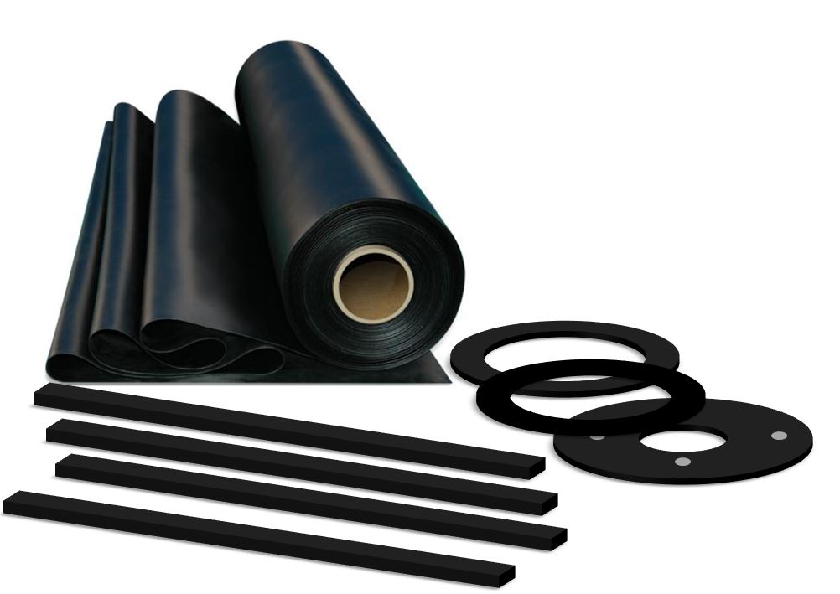

## TECHNICAL DATA

**image004**

**Inverness +44 (0) 1463 238 673**  **Head Office +44 (0) 141 620 1666 (8 lines)** **Ashford +44 (0) 1233 330 766**

[**sales@williamjohnston.co.uk**](mailto:sales@williamjohnston.co.uk)[**www.williamjohnston.co.uk**](http://www.williamjohnston.co.uk)

|  |  |
| --- | --- |
| PRODUCT NAME | Commercial SBR 65 |
| DESCRIPTION | A Styrene Butadiene Rubber with a Shore A hardness of 65. Cost effective and abrasion resistant |
| THICKNESS (mm) | **Click here to enter text.** |
| SHEET SIZE (M) | 1.4 x 10 |
| FINISH | Plate |
| MATERIAL | Styrene Butadiene |
| APPLICATION | Where abrasion resistance matters this blend is suitable for applications such as snow plough rubbers, scraper blades, wipers and hard chute lining. |
| INSERTION | No |
| CHEMICAL RESISTANCE | PLEASE REFER TO OUR CHEMICAL DATA SHEET |

|  |  |
| --- | --- |
| **SPECIFICATIONS COMPOUND** | **Values [typical]** |
| COLOUR | Black |
| COMPOUND | NR/SBR |
| DENSITY [SPECIFIC GRAVITY] g/cm³ | 1.5 |
| HARDNESS [DEGREES SHORE A] +/-5 | 65 |
| TENSILE STRENGTH MPa | 3 |
| ELONGATION AT BREAK % | 250 |
| MINIMUM TEMPERATURE °C | -30 |
| MAXIMUM TEMPERATURE °C | +70 (90 intermittent) |
| ABRASION RESISTANCE mm³ | 180 |
| COMPRESION SET 70 DEG 22 Hrs % | 30 |

## 

## 

## 

## 

## 

*As the companies’ products are used in multiple applications and as the company has no control over the method of their use, the company excludes all conditions or warranties, expressed or implied by statute or otherwise. Any technical co-operation is given for customers’ assistance only and without liability on the part of the company.*